**A Project-2 on**

Image Encryption & Decryption

**Submitted by**

Gyanapriya Pradhan (Regd No:F18029007008)

Asutosh Padhy (Regd No:F18029007007 )

Mubarak Ahmed (Regd No:F18029007010 )

Sandeep kumar (Regd No:F18029007017)

Pratyush kumar Jena (Regd No:F18029007011)

**of**

5th Sem / CSE Branch

**Under Supervision of:**

Mr. Amardeep Das

(Asst. Prof.)



**Department of Computer Science & Engineering**

**C. V. RAMAN POLYTECHNIC,**

**BHUBANESWAR**

2021

Declaration

This is to declare that the work in the Project 1 entitled “Image Encryption & Decryption using JAVA” submitted by, Gyanapriya Pradhan (Regd No.F18029007008), Asutosh Padhy (Regd No:F18029007007), Mubarak Ahmed(Regd No:F18029007010 ), Sandeep kumar (Regd No:F18029007017), Pratyush kumar jena (F18029007011) in partial fulfillment of the requirements for the 5th Semester for Bachelor of Technology with specialization in Computer Science & Engineering is a bona fide work carried out by us under the supervision and guidance of Mr. Amardeep Das (Asst. Prof.). It does not contain materials copied from other published work, and the work is not published anywhere.

**Name & Signature of students:**

Gyanapriya Pradhan (F18029007008)

Asutosh Padhy (F18029007007)

Mubarak Ahmed (F18029007010)

Sandeep kumar (F18029007017)

Pratyush Kumar Jena (F18029007011)

Certificate

This is to certify that we have examined the project report entitled “**Image Encryption and Decryption Using JAVA**” submitted by, Gyanapriya Pradhan (Regd No.-F18029007008), Asutosh Padhy (Regd No:F18029007007), Mubarak Ahmed (Regd No:F18029007010 ), Sandeep kumar (Regd No:F18029007017), Pratyush Kumar Jena(Regd No:F18029007011) CVRP, Bhubaneswar. We hereby accord our approval of the project-1 work carried out and presented in a manner required for its acceptance as per the academic regulation, for the partial fulfillment for the 5th Semester in Computer Science & Engineering. This approval does not necessarily endorse or accept every statement made, opinion expressed or conclusions drawn as recorded in this project . It only signifies the acceptance of the project for the purpose for which it has been submitted.

**Mr.Amardeep Das, Asst.prof Mrs.Prangya Paramita Mohapatra (Project Guide) Asst. Prof, HOD, CSE**

Acknowledgements

We are pleased to acknowledge (Asst. Prof.) Mr. Amardeep Das for his invaluable guidance during the course of this project work.

We extend our sincere thanks to our (HOD) Mrs. Prangya Paramita Mohapatra for the immeasurable support.

We are also grateful to other members of the CSE Department who co-operated with us regarding some issues.

Gyanapriya Pradhan (Redg No.F18029007008)

Asutosh Padhy (Regd No:F18029007007)

Mubarak Ahmed (Regd No:F18029007010)

Sandeep kumar (Regd No:F18029007017)

Pratyush Kumar Jena (Regd No:F18029007011)

**Abstract**

In today’s environment, security becomes an important issue in communication. For secure transmission of data in open network, encryption is very important methodology. Through encryption we can prevent our data from unauthorized access during transmission. In recent years many image encryption methods have been proposed and used to protect confidential data and encryption is given much attention in research of information security and a lot of image encryption algorithms have been introduced. Due to some intrinsic features of images like bulk data capacity and high data redundancy, the encryption of image is different from that of text; therefore it is difficult to handle them by traditional encryption methods. In the proposed work, a new image encryption algorithm based XOR Operation (bit array or bitwise Operation) is being applied. To begin with, the plain-image is converted into int of single bytes and then the int is replaced as the value of XOR Further, the control parameters of XOR Operation are selected randomly by the user. The experimental result shows that the proposed algorithm can successfully encrypt/decrypt the images with same secret keys, and the algorithm has good encryption effect. this method will be entirely different when compared to the original image file and will be suitable for the secured transmission over the internet. Thus, this model provides an additional level of security to an image and efficient utilization of memory.

Keywords: *awt ,javaswing, jframe, jtextfield, textarea, checkbox, jbutton, jpanel, jfilechooser, javaio, javafis, javafos*.

Contents

**CERTIFICATE …………………………………………………………………………………… …1**

**DECLARATION ………………………………………………………………………………………2**

**ACKNOWLEDGEMENTS.....................................................................................................................3**

**ABSTRACT ..............................................................................................................................................4**

**CONTENTS ……………………………………………………………………………………………5**

**INTRODUCTION.....................................................................................................................................6**

**METHODOLOGY....................................................................................................................................7**

**RESULT / OUTCOME ……………………………………………………………………………… 15**

**CONCLUSION………………………………………………………………………………………... 16**

Chapter 1

**INTRODUCTION**

In the current trends, the technologies have been advanced. Most of the individuals prefer using the internet as the primary medium to transfer data from one end to another across the internet. There are many possible ways to transmit data using the internet like: via e-mails, sending text and images, etc. In the present communication world, images are widely in use. However, one of the main problems with sending data over the Internet is the ‘security’ and authenticity. Data security basically means protection of datafrom unauthorized users or attackers. Encryption is one of the technique for the information security. Image encryption is a technique that convert original image to another form that is difficult to understand. No one can access the content without knowing a decryption key. Image encryption has applications in corporate world, health care, military operations, and multimedia systems. Encryption is the process of encoding plain text message into cipher text message where as reverse process of transforming cipher text to plain text is called as decryption. Cryptography consists of encryption and decryption techniques. In this paper we have discuss about the XOR Operation or Bitwise Operation Algorithm techniques to Encrypt or Decrypt Image.

***What is Encryption ?***

Encryption is a process which uses a finite set of instruction called an algorithm to convert original message, known as plaintext, into cipher text, its encrypted form. Cryptographic algorithms normally require a set of characters called a key to encrypt or decrypt data. With the help of key and the algorithm we can encrypt or Decrypt the plaintext into cipher text and then cipher text back into plaintext.

***Why Encryption and Why Image Encryption ?***

Nowadays, information security is becoming more important in data storage and transmission. Images are widely used in different-different processes. Therefore, the security of image data from unauthorized uses is important. Image encryption plays a important role in the field of information hiding. Image encryption method prepared information unreadable. Therefore, no hacker or eavesdropper, including server administrators and others, have access to original message or any other type of transmitted information through public networks such as internet.

***REQUIREMENTS OF IMAGE ENCRYPTION :***

Ability to get the pixels of the original image. Create a strong encryption image such that it cannot be hacked easily. Faster encryption time such that encrypted image is transferred faster to the person. Perfection in the original image we obtain after decrypting it.

***Software Requirements :***

* Operating System : Windows
* IDE : Netbeans and Visual studio code etc.
* Coding Language : JAVA
* Runtime path : JRE 8

**METHODOLOGY :**

***PROJECT DESIGN & ALGORITHM :***

In these cases also we will do the same, For encryption, we will convert the image into a byte array and after converting it we will apply XOR operation on each value of the byte array and after performing XOR operation on each and every value of byte array will be changed. After performing the operation now we will write new data in Image due to which we are unable to open the Encrypted Image. Here are key will act as a password to Encrypt and Decrypt the Image.

***XOR Operation:***

As we know that how to perform XOR operation now we will see how XOR operation will work here. Let’s consider an example of sample input and output.

Example 1:

Input :

int key = 8

int byte_val = 5

Encryption Operation:

// Performing XOR operation between key and byte_val

key ^ byte_val

Output:

// Output of XOR operation

13

Decryption Operation:

// Performing XOR operation between output and key

13 ^ key

Output:

// byte_val

5

Here, is the screenshot of the above example. Let’s have a look

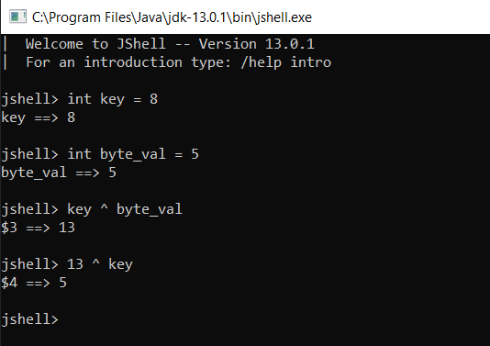

In the above example, we have clearly observed that our key = 8 and byte_val = 5, and When we perform XOR operation on key and byte_val it gives the output as 13, now if we again perform XOR operation on our output “13” and key, we get our byte_val again. The same operation performed in the case of Encryption and Decryption as well.

XOR operation performed between each and every value of byte array and key due to which all data of Image get change and due to which we are unable to open our Image. Now, whenever we apply a Decryption operation with the same key-value byte array value get the change to its original value and able to see our original Image.

***Note :***

***Encryption :*** Key act as Password to Decrypt the same Image, use the same key otherwise it will corrupt the Image.

Enter key for Encryption : eg.1234

Encyption Done…

***Decryption :*** means the conversion of encrypted data into its original form is nothing but Decryption. In the case of Image Decryption as well we convert out encrypted Image into its original form. Here we will use XOR operation to perform decryption as well. As we observe in the above example of XOR that how we get our original value of byte array by performing XOR operation on output and key value. Same logic we will use here.

***Project Design and GUI :***

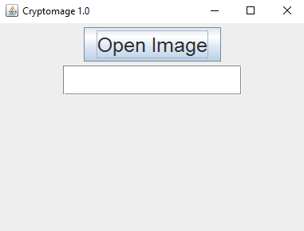

***AWT (abstract Windowing tool):***

* Java AWT (Abstract Window Toolkit) is an API to develop GUI or window-based applications in java.
* Java AWT components are platform-dependent i.e. components are displayed according to the view of operating system. AWT is heavyweight i.e. its components are using the resources of OS.
* The java.awt package provides classes for AWT api such as TextField, Label, TextArea, RadioButton, CheckBox, Choice, List etc.
* Methods :
  + - awt.font
    - awt.flowlayout

***JAVA Swing :***

* Java Swing tutorial is a part of Java Foundation Classes (JFC) that is used to create window-based applications. It is built on the top of AWT (Abstract Windowing Toolkit) API and entirely written in java.
* Unlike AWT, Java Swing provides platform-independent and lightweight components.
* The javax.swing package provides classes for java swing API such as JButton, JTextField, JTextArea, JRadioButton, JCheckbox, JMenu, JColorChooser etc.
* Method used
* javax.swing.Jframe (to constuct a new frame)
* Jbutton (with actionlistener)
* Joptionpane
* Jtextfield
* Jpanel
* Jfilechooser

***Java I/O (input output) :***

* Java I/O (Input and Output) is used to process the input and produce the output.
* Java uses the concept of a stream to make I/O operation fast. The java.io package contains all the classes required for input and output operations.
* We can perform file handling in Java by Java I/O API.

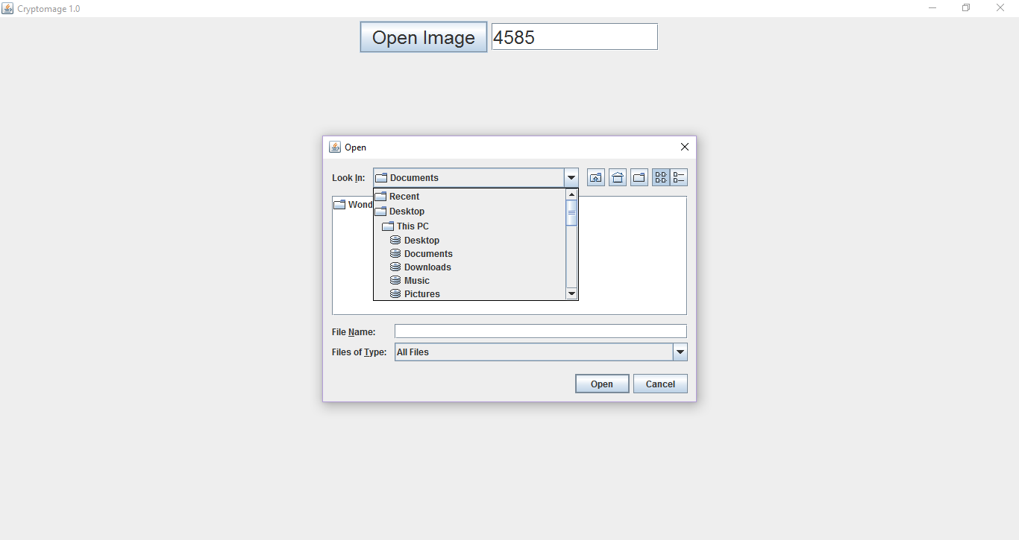

***Java FileInputStream :***

Java FileInputStream class obtains input bytes from a file. It is used for reading byte-oriented data (streams of raw bytes) such as image data, audio, video etc. You can also read character-stream data. But, for reading streams of characters, it is recommended to use FileReader class.

* Method : i. java.io.FileInputStream

***Java FileOutputStream :***

* This is an output stream used for writing data to a file.
* If you have to write primitive values into a file, use FileOutputStream class. You can write byte-oriented as well as character-oriented data through FileOutputStream class. But, for character-oriented data, it is preferred to use FileWriter than FileOutputStream.
* Method : java.io.FileOutputStream

***Final Implementations:***

To complete this program we need to pass an object to this actionlistener but in this GUI building there is no object so we need to create another class for this operation which is called childclass, After implementing actionlistener to the childclass then we need to pass that childclass object to main source. Instead of this method we can use lamda function (e->{}) this is used for any anonymous class to implement functional interface.

* Method used : button.addActionListener(e->{})

*\* for key and integer variable will use parseint fuction to convert the text into integer into temp for further decryption operation.*

**MODULES :-**

**User Module :**

* Run the Program in any java IDE
* GUI will Open
* Select the image file to be Executed

**Encryption Module :**

* Provide any Numerical Character Keyword for Encryption
* Select the image by clicking open image button
* Encryption is Done.

**Decryption Module :**

* Provide the same numerical character keyword as you provided before while Encrypting.
* Select the same Image open image Button.
* Decryption is done.

**RESULT / OUTCOME :**

***Case 1:***

***Before Encryption:***

***After Encryption:***

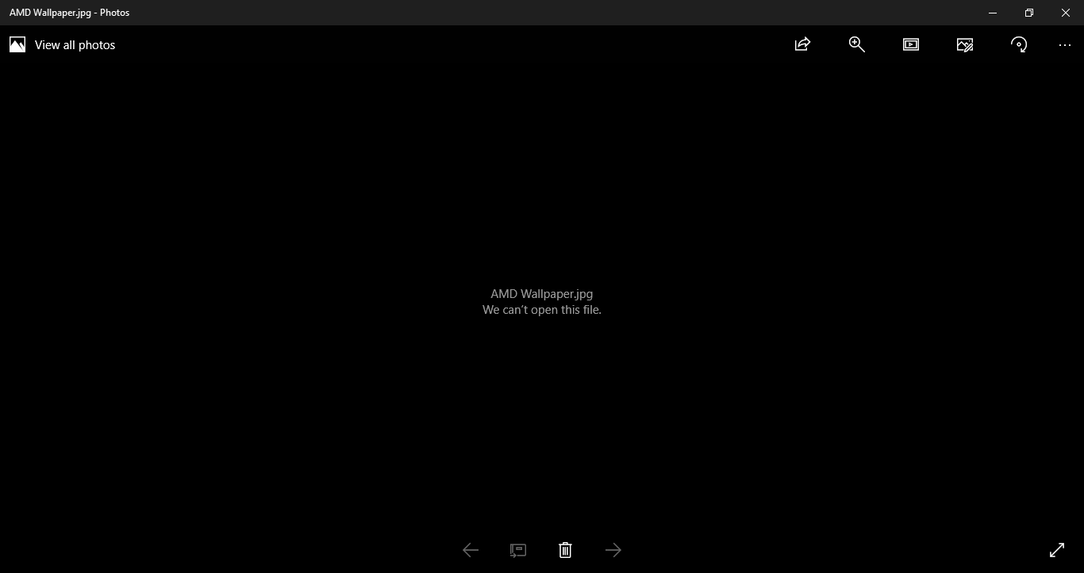

***CONCLUSION :***

Thus, the project entitled “Image Encryption and Decryption ” was successfully completed. A simplex project involving the conversion of image into Bitwise form, using a mathematical concept to encrypt and decrypt it a same way,it was instrumental in giving us a thorough understanding of how the concepts of XOR Operation in java can actually be implemented in the real world. By the end of the project, we have gained valuable skills including a grounding of how to interact with the Java IDE, GUI making in java, algorithms, calculating the efficiencies, and learning how to form and manipulate images.

References :

<https://stackoverflow.com/questions/13641563/xor-cipher-in-java-php-different-results/>

<https://www.geeksforgeeks.org/encrypt-and-decrypt-image-using-java/>

<https://www.codota.com/code/java/methods/java.io.FileInputStream/available/>

<https://www.javatpoint.com/>

<https://www.guru99.com/java-swing-gui.html/>